
Ceiling Speaker TCI-105

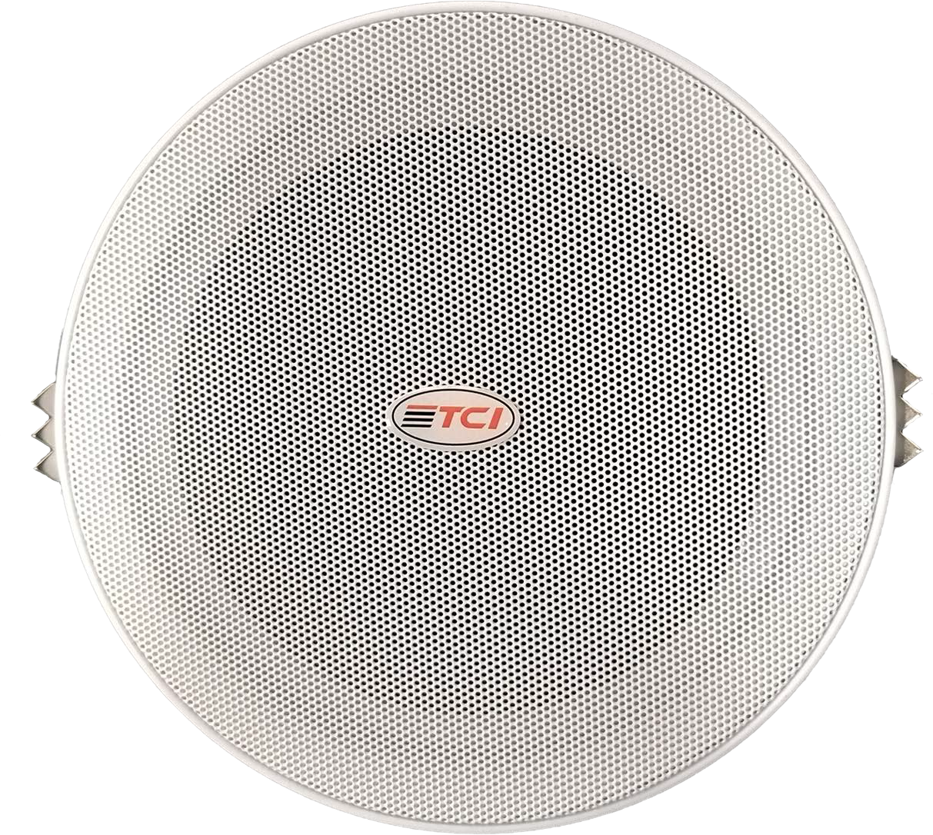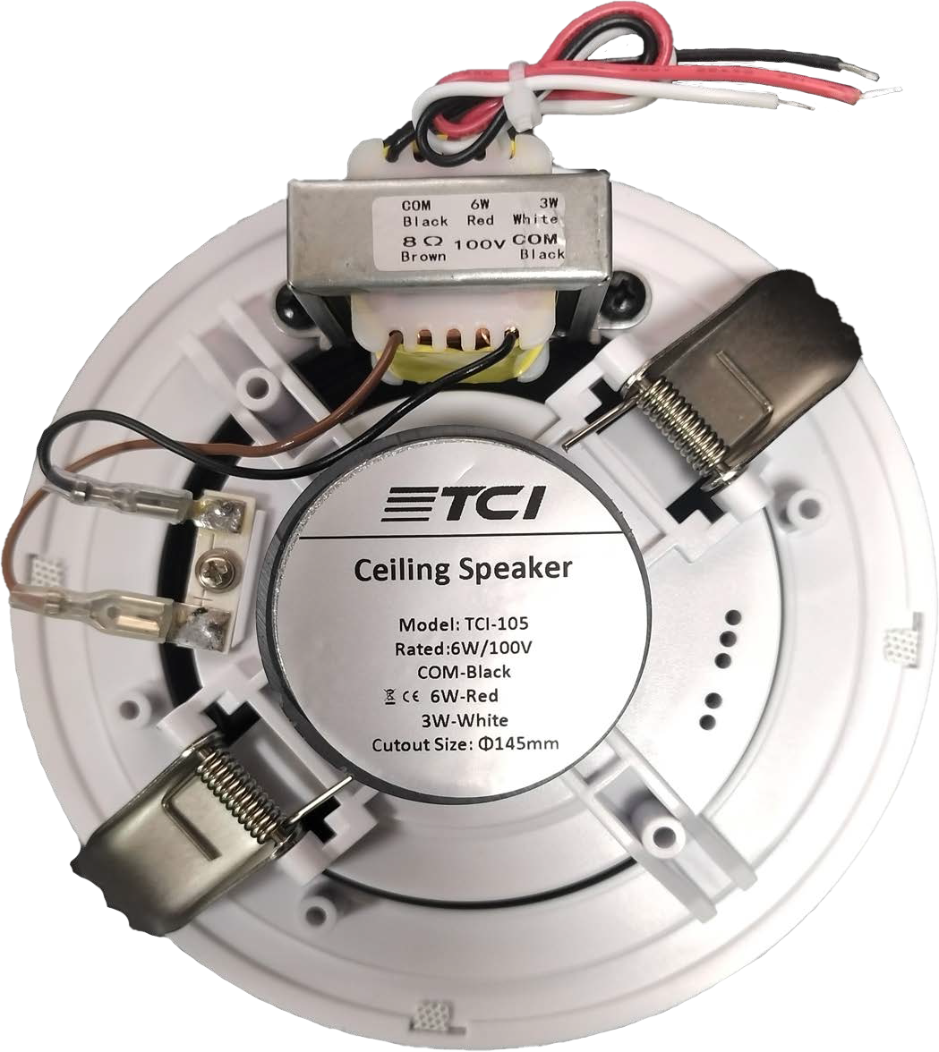

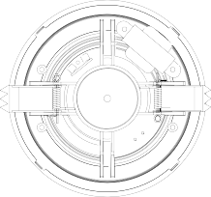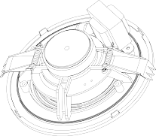

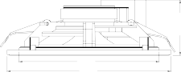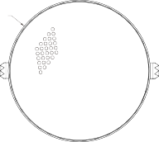┐╠Â╚25.400
Φ145
Φ160
Φ160mm
54mm
General Specification
Model | TCI-105
Frequency Response | 100-15KHz
SPL | 97dB at 100V 3W
Sensitivity | 93±3dB
Power Handling | 6W
Power Taps | 3W/6W
Line input | 100V
Hole for mounting | Φ145mm
Dimension(D*H) | Φ160*54mm
Physical Specification
Material | ABS( adull white)
Grille | Powder Coated Aluminum Mesh
Grille | (White ral 9016)
Component | 5"
Finished Colour | White
Unit Weight | 0.45Kg
Speaker Specification
Voice Coil Size | PSV14.28*Φ0.1*2T
DC Impedance | 7.2Ω
Former | Paper
Magnet | Ferrite(105g)
Magnet | Φ55*24*10(Y30)
Basket | ABS
Cone Material | Paper
Spider | Cloth
Dust cap | Paper Cup
Net Weight | 360g

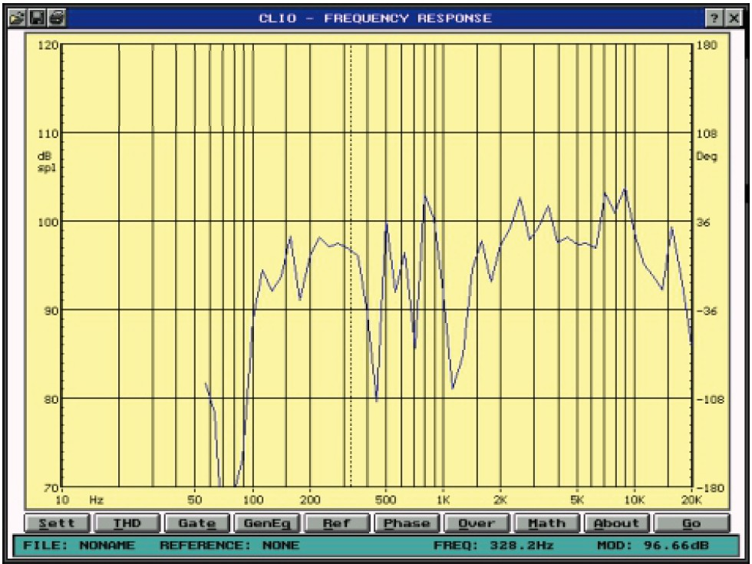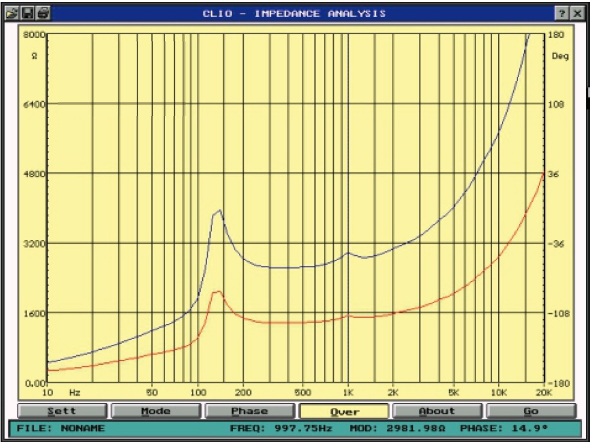

Page 1
www.TciTech.com.tr

